Invention Disclosure Form  Graphic Era Hill University, Dehradun  www.gehu.ac.in |  | FOR USE BY IPR Cell
 |  | DATE FORM RECEIVED | NLO FILE NO.
INSTRUCTIONS: Fill each blank with the requested information or enter "NONE" as appropriate. Where space on the form is inadequate, enter "see attached page" and use plain pages as needed. When completely executed, this form becomes an important legal document useful in proving priority of invention. After completing, hand over in person to: IPR Cell, GEHU. You may also email at ip@gehu.ac.in. If you have any questions, feel free to contact us.
PART I. BASIC INFORMATION
1a. DESCRIPTIVE INVENTION TITLE.

1b. INVENTOR(S) | Department and affiliation | Designation | Email-id
Deepankar Sharma |  | student | DEEPANKARSHARMA.20041299@gehu.ac.in

1c. OWNER. Do the above inventor(s) own the patent rights to this invention (check one)? [ ] Yes [ ] No If you answered "No," please identify the owner of the invention below including the state/country of organization for the company along with the company's mailing address.

1d. PRIOR USE, SALE OR PUBLICATION. Identify any past use, sale, display or publication of the invention (include dates).

1e. RELATED PATENTS OR APPLICATIONS. List any related patents or patent applications of yours.

PART II. DISCLOSURE OF INVENTION
2a. PURPOSE. State the purpose of the invention.

The lives of people is already getting busier everyday. In most families involving both parents working are prone to insufficient parenting, as small babies can’t exactly say what they want and parents might be too busy to figure it out.
2b. PRIOR EXISTING TECHNOLOGY. Describe the previous old methods, materials or apparatus used by others to perform the purpose of the invention and give their limitations/disadvantages.

Usually most parents hire someone else to do the childcare of their babies in their working hours. This next person might be someone in family or someone on paid basis. But being human , a third person, being not a parent might not always be that much sensitive to your baby. Their minds maybe preoccupied.

2c. PHYSICAL STRUCTURE. Describe the physical structure of your invention (if applicable). Sketches, photos, or other illustrations should be attached to this form to fully illustrate your invention. In the description of the physical structure, use reference characters to refer to components in attached illustrations.

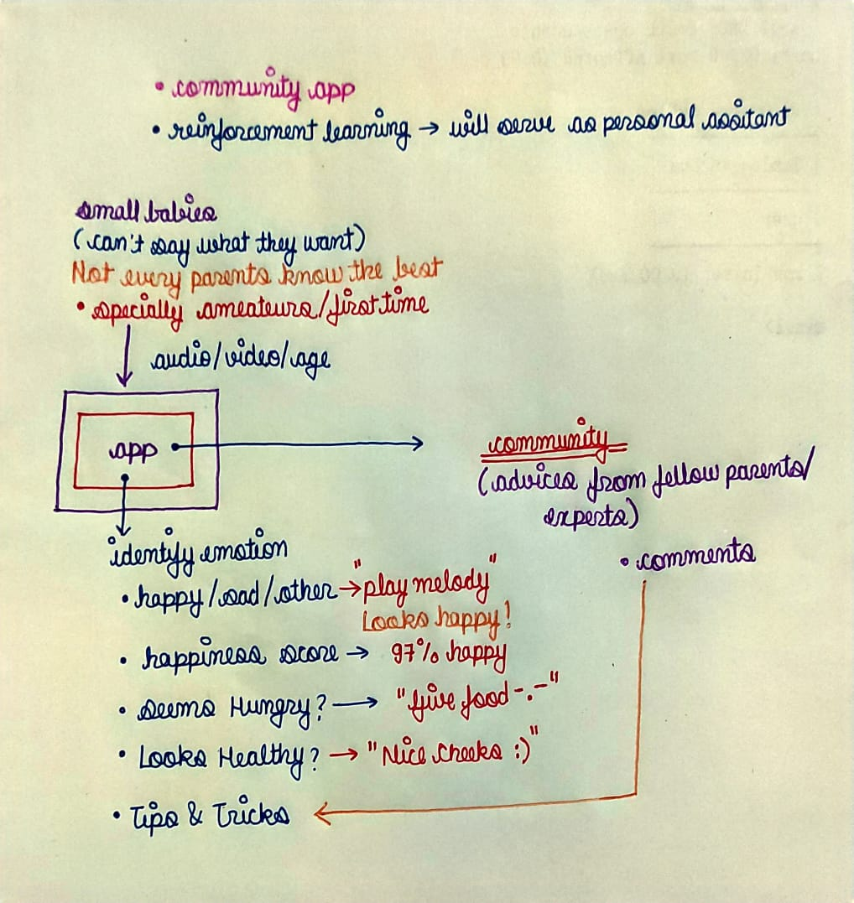

2d. OPERATION/FUNCTION/USE. Give a detailed description of the invention's operation, function and use.

The idea is to develop a full-fledged AI automated application with a Facial Mood Detection Classifier trained specially on datasets of small babies which can help you detect the current mood of the baby that whether they are happy/sad or they seem to be hungry. The app will also have another features like growth-vs-age mapping of various children that can help you track the growth of your child, The voice of child is supposed to be another useful task for the purpose.
This app is supposed to be serving as a self-customized application which will learn to deal with specifically your child. It would be made flexible so that with time it’ll learn from habits of the specific children it’s serving to.
Another feature , the app will come with a community environment , where you can seek for advice from fellow parents/experts. Everyone knows some life hacks, so the users might will have possibly many many better options of childcare.
The application will also have various inbuilt melodies and songs as well as access to music applications or youtube which it can play/recommend according to the mood of the child.

2e. ALTERNATIVES. Indicate any alternative methods, materials, or apparatus of the invention.

In order to make this application cost effective , we can use Cloud as a Service.

2f. NEW FEATURES. Identify the features of the invention believed to be new.

This application is supposed to be one of it’s kind , because it’ll also learn from the habits of the children its serving to and call always be customized. This application will provide all effective tools at one place that will help parents with effective parenting. Besides if deployed in form of robots it can serve as a best buddy to many children.

2g. ADVANTAGES. State the advantages of the invention over the Prior Existing Technology described in paragraph 2b.

But being human , a third person, being not a parent might not always be that much sensitive to your baby. Their minds maybe preoccupied.
This application will be always serving an effective childcare. Not all babies are same , so it’ll learn to deal according to specifically your own child.

PART III. PERSON SUBMITTING FORM
FULL NAME | SUBMISSION DATE
MAILING ADDRESS | BUSINESS TELEPHONE
E-MAIL ADDRESS | CELL PHONE

